Installation Instructions PVC Window


- Place new window into opening and even out spacing between Brickmold and stucco or between window box frame and rough opening.
- Remove screen from window and set aside.
- Shim window bottom at specific locations Figure 1-2-3 according to the window type.
- Install plastic handle cover and handle onto crank screw.
- Once window is leveled proceed to screw window to framing, being careful not to overdue screw pressure on the pvc frame. Screws can be applied into brickmold of window behind color stripe. Screws can also be installed through the window frame in specific areas with the use of pvc buttons to hide the screws ( please contact THE WINDOW FACTORY to confirm location of through the frame screws)
- Once window is fastened operate unit to determine smooth operation, being careful to examine window to identify any screw over-pressure or bowing. If required loosen screws or adjust shims
- On Casement or Awning windows please verify the exterior weatherseal is even all around the sash. If weatherseal is uneven adjust the screws or shims of the operating window to bring weatherseal into even contact with frame Figure 4 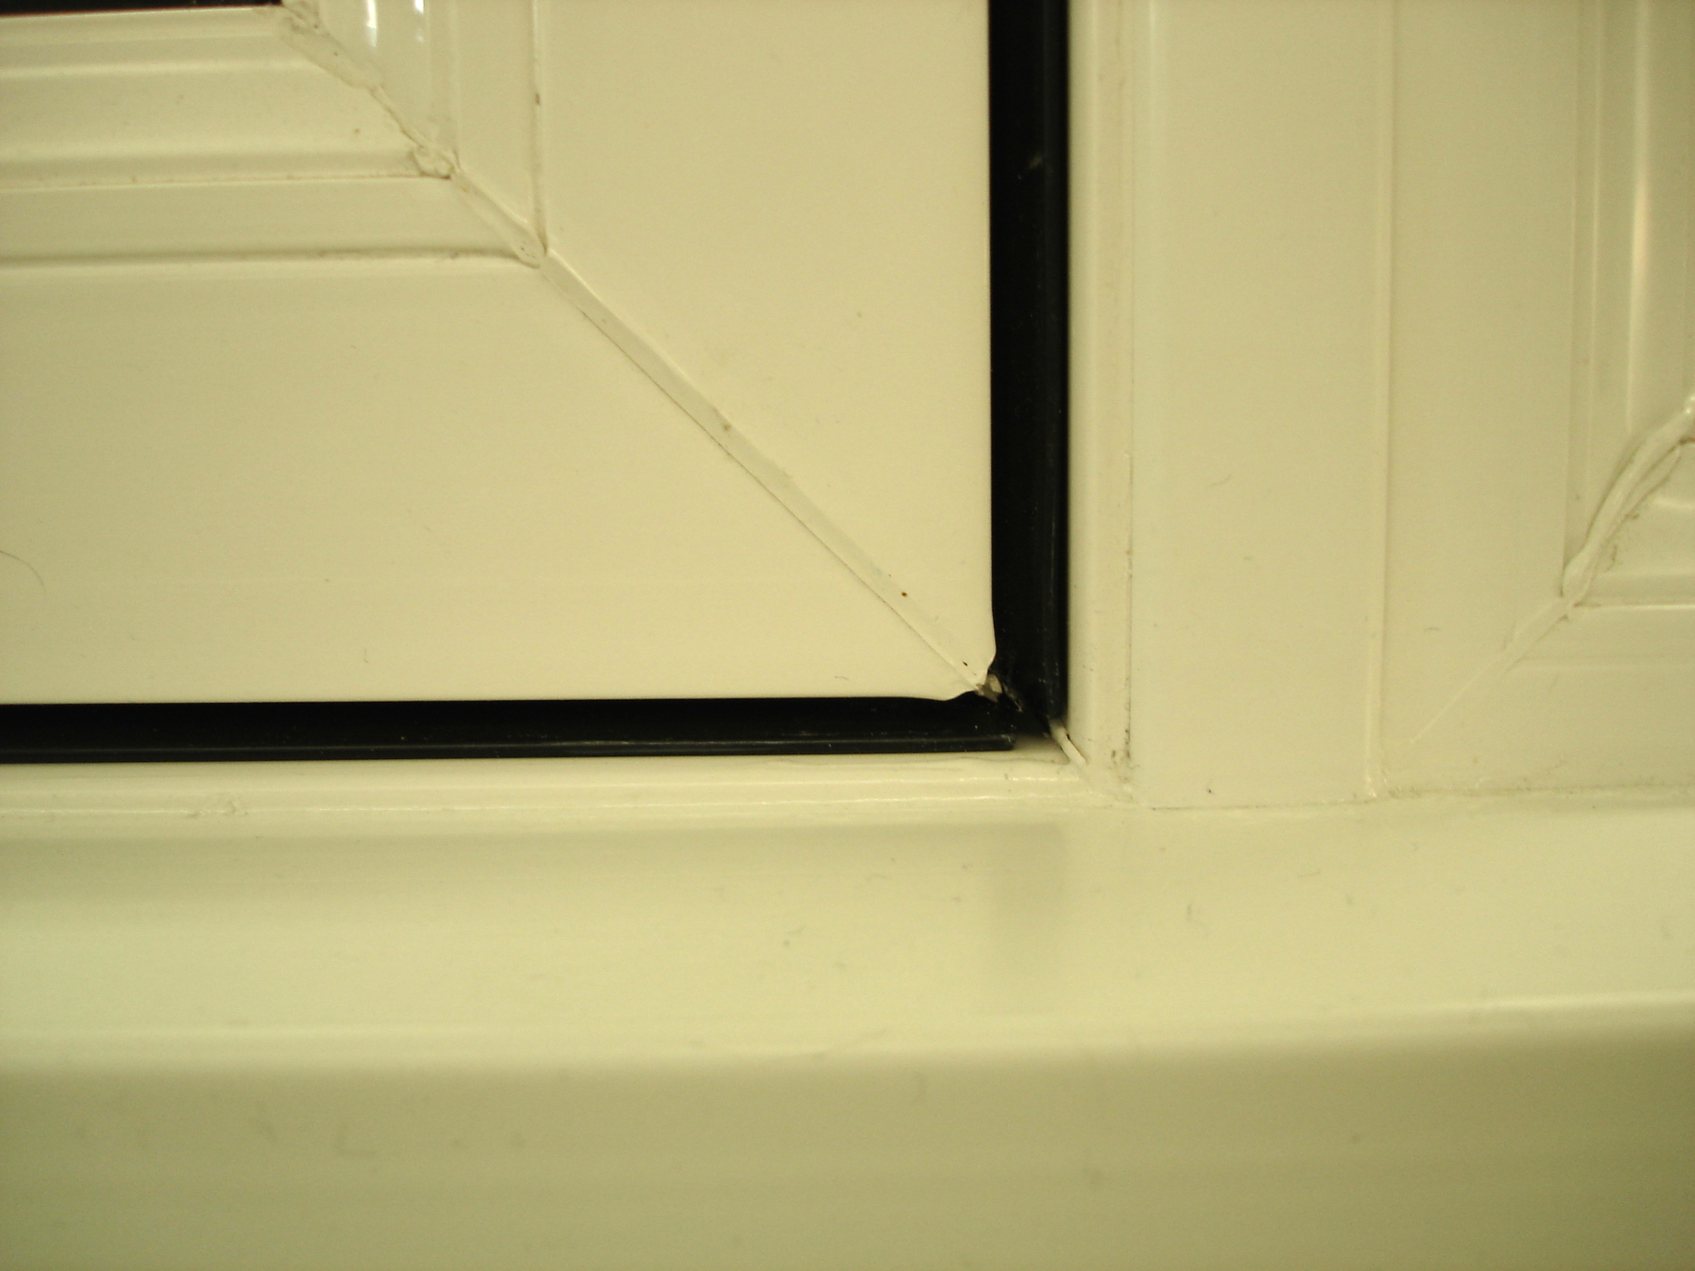

- Insulate frame of window to rough opening ( if using expanding foam insulation be sure to use low expansion foam and do not over foam)
- On exterior, seal window placed into stucco with a quality caulking bead. Into new construction the use of a membrane seal around the exterior of the window flange is recommended.
- Clean window using a mild detergent and replace screen which was removed earlier.

Fig. 1 Fig. 2 Fig. 3



